Refresh Network System & Hardware Component
Mahmudul Alam
Colorado State University – Global Campus
Course Code: 20FA-CSC501-1
Dr. Charles Beverley
Sunday, July 26, 2020
Refresh Network System & Hardware Component
A network system supports workstations, connections to the personal computers and connects internet of things to the local area network. IOT devices, hardware components and software capability changes as time progresses. Every company invests a lot financial capital towards buying and maintaining technologies. Refreshing network and laptop equipment is part of maintaining this large capital investment to increase proficiency and efficiency of the company. There are many ways a network system and hardware can be refreshed including replacing some hardware component, installing a new software, buying new routers, servers, adding fast data cables. Refreshing a network will save lots of money for the company in the long run, also it will make the company competitive with better technical capabilities.
Purpose of Network and Hardware Refresh
Technologies are improving every day, and the old equipment and system becomes less efficient with change in time. Networking equipment has a life range of up to 10 years. Network switches, routers and cables becomes obsolete after certain amount of time. If we are not planning to replace and upgrade those items, the whole organization can be in grave danger of not functioning properly, due to the slow systems and delay replacing those parts a company can be in grave danger. According to Network refresh guide, there are many potential problems an organization could avoid if the network refresh is done properly on time. “Upgraded software and hardware can maximize performance. It can improve IT performance, reduce operating expenses, increase security, meet compliance standards, gain advantage over competitors.” This phase of maintenance is like paying salary to employees, without paying employees you can not have a business similarly without the right equipment and network refresh company’s system will fail.

Plans to Carry out Phases
We have 150 different employees over 48 different states and it is time for a network and hardware refresh. There are two to three switches per site which makes it total of 96-144 switches. Also, we are counting one personal machine per person and few extra for guest users, total of 150- 170 machines. Currently we are using a local server to operate our day to day business. Our company provides financial support to our clients. We have few options on our hand, replace all the old hardware for the internal network and replace parts for the laptops and other computers to have the best possible performance. The other option is to migrate to a cloud-based system for networks and hardware. “Private cloud services are defined as being operated by an organization for which hardware, networking, storage, and other infrastructure are not directly shared with other organizations.”( K. Blaylock), private cloud computing could provide all the support we need. We are a financial company we deal with lots of data which needs to be stored in a secure server and at the same time accessible. Amazon web service just provides that, we can have access to the machines virtually which are build only for us, that way we don’t have to deal with the internal networking issues neither we have to take care the refreshing aspect of it.
AWS service can be the best possible solution considering the financial point of view, reliability, user experience, data storage, automatic updated hardware which will always give us the best performance possible. We will connect our company to the AWS platform first which will be VPN protected, we will have direct access to the machines hosted by the AWS infrastructure, we can add many as user needed to our system with the AWS. This diagram below shows how exactly the whole system will be set up to support all the employees.
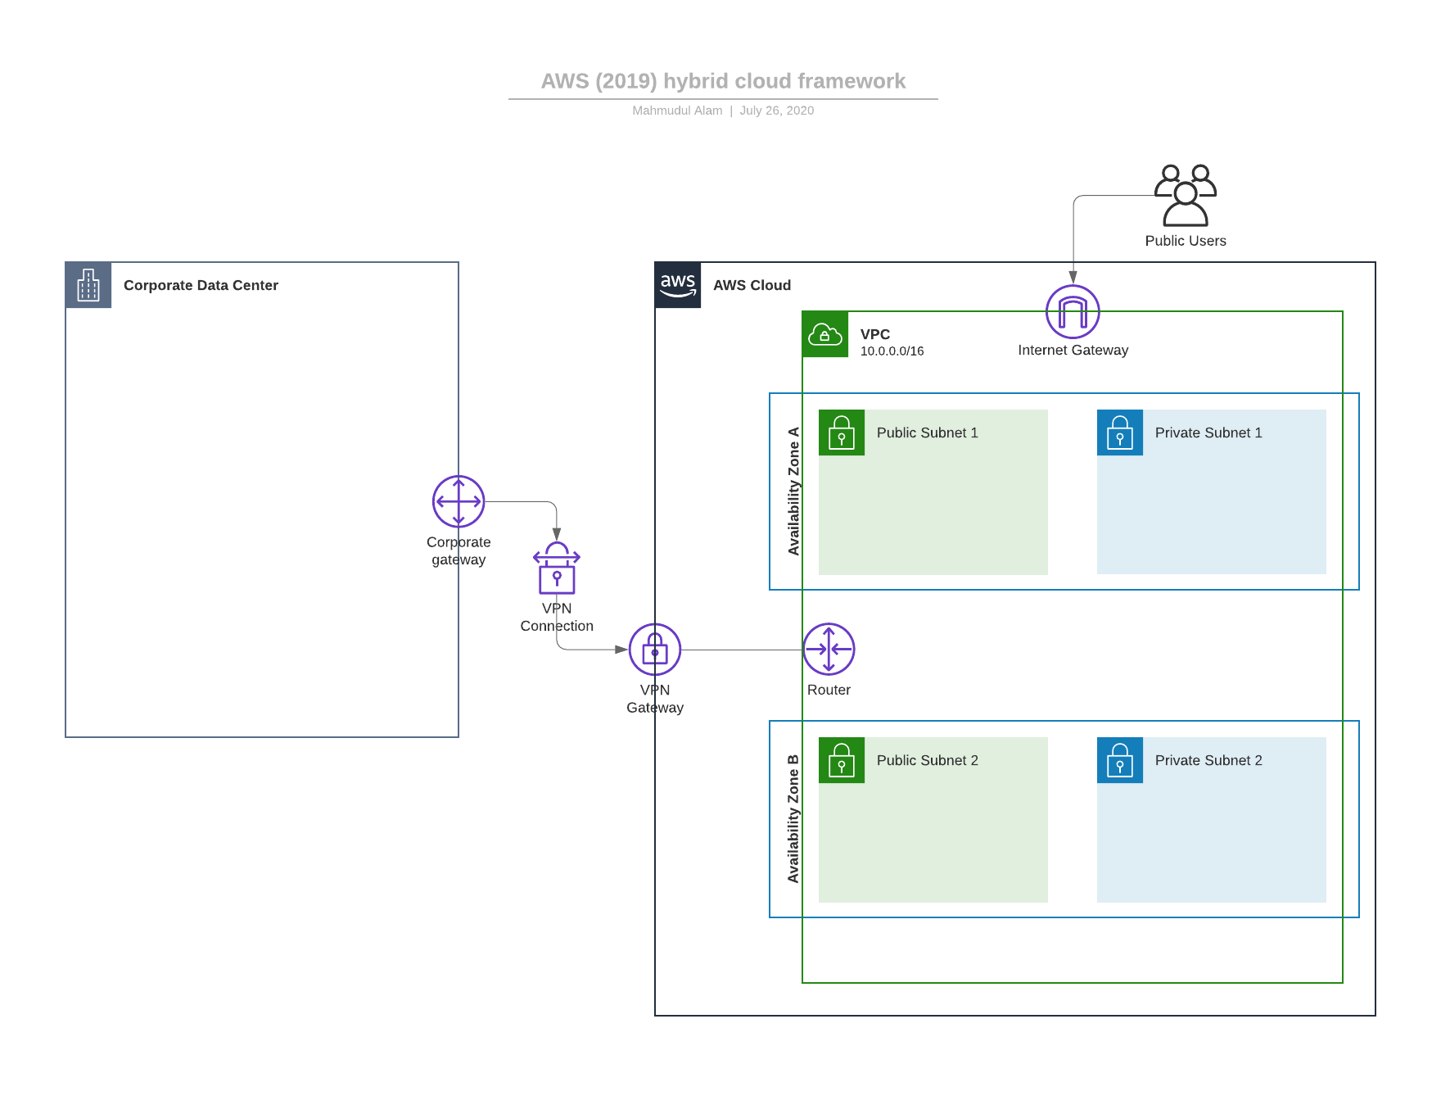
Credit for this diagram goes to lucidchart.com
Execute the Plan and Deliver a Refreshed Network
IT infrastructures and Network systems plays a critical role for an organization. The purpose of refreshing a network system is to provide better standard or working flow for the users/organization. For our company we are taking a little different route and migrating to a cloud-based system. While migrating we must make sure everything is working smoothly, during migrating and even after migration, training people accordingly is part of the success. Having a plan is half the work done, making sure everything goes accordingly is other half of the process. There are many procedures related to cloud migration to make sure the whole process goes smoothly.
“This work demonstrates the issues which the decision makers are facing in the case of evaluating the feasibility of the migration legacy system in organization into cloud computing. Furthermore, describes our technology toolkit, which has developed to support this process. The efﬁciency of the proposed technology toolkit has being evaluated under testing as a case study that is exploring options to choosing deployment and cloud service models.” ( SAIF MUHAMED)
People are working around the world to make cloud computing easier for the legacy systems to migrate over the cloud. Staying up to current technology is part if the network refresh. Bringing business over the AWS will give us the best technical tools to utilize. We do not have to worry about the IT, IOT, Internal Network, storage and physical hardware, we can mainly focus on improving the business and the core principles and products.
Steps for our network system and hardware serverless migration. First, we are going to have enough servers and database calculated for our users and data. Based on the estimation we are going to buy some private servers and make sure enough user profile is created. Once that is done, we will migrate our legacy system over AWS while recent changes stays on local servers, once that is completed we will have an update over the weekend to make sure everything is parallel with the local machines. We will remove all the all the hardware and internal network systems and have everyone use the AWS product with proper username and login.
Conclusion
Technology is forever changing, and it is difficult to update all the IT infrastructures as frequent as possible. As part of our financial company’s project management plan for refreshing network and hardware, AWS cloud bases services and infrastructures provides us with the best possible solution. Using AWS we do not have to reinvent maintain our hardware and network components after certain amount of time rather we pay fraction of the cost to AWS to maintain and updated hardware and network related issues. We can always be up to date with their services while focusing on the objective of the company. We can hire more people to redefine products and services we provide and how can we make our company better. Cloud computing is the future of computing and serverless systems. Our organization will be better off by migrating over cloud and we will have greater margin of profit.

References
Network refresh guide—The most effective way to refresh your network in 2020. (2019,
December 6). D-Link Business Blog. https://businessblog.us.dlink.com/network-refresh-guide/
K. Blaylock, B., D. Horel, J., &amp; T. Liston, S. (2017, December). Cloud archiving and data
mining of High-Resolution Rapid Refresh forecast model output. Retrieved July 26, 2020 from /csuglobal.idm.oclc.org/science/article/pii/S0098300417305083
SAIF MUHAMED; MOHAMMED MOHAMMED; THAKER NAYL. Case Study for
Migration from on Premise to Cloud. Iraqi Journal for Computers and Informatics, [s. l.], v. 45, n. 2, p. 15–19, 2019. DOI 10.25195/ijci.v45i2.48. Disponível em: http://search.ebscohost.com/login.aspx?direct=true&db=edsdoj&AN=edsdoj.f5baa6b1ded47238ccd12ae2d0fa840&site=eds-live. Acesso em: 26 jul. 2020.

